PERIODICO TCHE QUIMICA



**ARTIGO ORIGINAL**

PATRIMONIO MATEMATICO DE AL-FARABI E UMA ABORDAGEM ALGORITMICA A  
SOLUQAO DE PROBLEMAS EM CONSTRUQOES GEOMETRICAS NO AMBIENTE  
GEOGEBRA

AL-FARABI'S MATHEMATICAL LEGACY AND ALGORITHMIC APPROACH TO  
RESOLVING PROBLEMS REGARDING GEOMETRICAL CONSTRUCTIONS IN  
GEOGEBRA ENVIRONMENT

МАТЕМАТИЧЕСКОЕ НАСЛЕДИЕ АЛЬ-ФАРАБИ И АЛГОРИТМИЧЕСКИЙ ПОДХОД К  
РЕШЕНИЮ ЗАДАЧ НА ГЕОМЕТРИЧЕСКИЕ ПОСТРОЕНИЯ В СРЕДЕ GEOGEBRA

BIDAIBEKOV, Yessen1*; GRINSHKUN, Vadim2; BOSTANOV, Bektas3; UMBETBAYEV,  
Kairat4; MYRSYDYKOV, Yerles5;

1,3,4 Abai Kazakh National Pedagogical University, Department of Informatics and Informatization of Education,

13 Dostyk Ave., zip code 050010, Almaty - Republic of Kazakhstan

2 Moscow City University, Department of Informatization of Education, 4 Vtoroy Selskohoziajstvenny Proezd, zip  
code 129226, Moscow - Russian Federation

5 Nazarbayev Intellectual School, 21/1 Hussein ben Talal Str., zip code 010000, Astana - Republic of  
Kazakhstan

*\* Correspondence author  
e-mail: [esen_bidaibekov@mail.ru](mailto:esen_bidaibekov@mail.ru)*

Received 22 December 2019; received in revised form 05 March 2020; accepted 09 March 2020

RESUMO

Al-Farabi deixou uma heranga cientffica rica para as geragoes futuras, incluindo pesquisas em varios campos da ciencia. Atualmente seus trabalhos ainda sao uteis, pois sao de grande interesse para a comunidade cienUfica. A relevancia deste estudo, que se liga aos desenhos geometricos feitos por Al-Farabi para o ensino moderno de matematica e engenharia, reside no uso exclusivo da abordagem algoritmica para resolver problemas matematicos e pesquisas aplicadas. Essas abordagens algoritmicas permitem criar as ferramentas de aprendizagem didaticos com base no uso da tecnologia de processamento de informagoes. Um dos prindpios basicos de Al-Farabi e o estudo e a consideragao da matematica em termos de fenomenos e processos naturais, bem como todos os tipos de sua implementagao pratica. Este artigo e dedicado ao estudo da heranga matematica de Al-Farabi em relagao a problemas geometricos de construgao, bem como ao desenvolvimento de metodos para resolve-los usando modernas tecnologias da informagao, em particular, usando o sistema de geometria dinamica GeoGebra, que e um ambiente para resolver problemas matematicos projetado para estudar, transformar e visualizar os modelos geometricos de objetos. O artigo cienUfico fornece os exemplos de solugao de problemas de construgao geometrica usando uma bussola matematica e uma regua, baseadas no algoritmo de construgao geometrica de Al-Farabi. Os autores gostariam de familiarizar o publico-alvo com os algoritmos desenvolvidos por Al-Farabi e sua implementagao de software. Para isso, foi criado um portal cienUfico e educacional para pesquisadores interessados, e os educadores podem encontrar muitas informagoes uteis e interessantes.

**Palavras-chave**: *heranga matematica de Al-Farabi, GeoGebra, problemas de construgao geometrica, trigonometria, portal educacional.*

ABSTRACT

Al-Farabi had left a rich scientific heritage for the succeeding generations including studies in various scientific areas. So far, his proceedings are still valuable being of great interest in the scientific society. The actuality of analyzing the problems with regard to geometric constructions accomplished by Al-Farabi for modern mathematical and engineering education lies in the unique character of Al-Farabi's efforts involving the use of the algorithmic approach for resolving mathematical problems and application-oriented researches. These algorithmic approaches enable the creation of didactic teaching techniques based on the use of information processing technology. One of the main Al-Farabi's principles is to study and consider the mathematics in terms of natural phenomena and processes as well as all types of its practical implementation. This article pursues studying Al- Farabi's mathematical heritage concerning geometrical construction problems as well as the development of their solution methods using modern information technology, in particular, using the GeoGebra dynamic geometry system which is a problem-solving environment designed for studying, conversion and visualization of geometric object models. This scientific article shows examples of resolving geometric construction problems using only a mathematical compass and a ruler by the Al-Farabi's procedures as well as problems for dividing squares and spheres and giving Al-Farabi's visual evidence of proving Ptolemy's theory from trigonometry area. The authors are interested in a targeted audience to familiarize themselves with algorithms developed by Al-Farabi and this software implementation; for this purpose, a scientific-education portal has been designed for the concerned researches and pedagogues may find out a lot of useful and interesting information.

**Keywords**: Al-Farabi's mathematical heritage, GeoGebra, geometric construction problems, trigonometry, educational portal

АННОТАЦИЯ

Аль-Фараби оставил богатое научное наследие для будущих поколений, включая исследования в различных научных областях. И сегодня его труды по-прежнему ценны тем, что представляют большой интерес для научного общества. Актуальность данного исследования, которое связано с геометрическими конструкциями, выполненными Аль-Фараби для современного математического и инженерного образования, заключается в уникальном использовании алгоритмического подхода для решения математических задач и прикладных исследований. Эти алгоритмические подходы позволяют создавать дидактические средства обучения, основанные на использовании технологии обработки информации. Одним из основных принципов Аль-Фараби является изучение и рассмотрение математики с точки зрения природных явлений и процессов, а также всех видов ее практической реализации. Эта статья посвящена изучению математического наследия Аль-Фараби в отношении задач геометрического построения, а также разработке методов их решения с использованием современных информационных технологий, в частности, с использованием системы динамической геометрии GeoGebra, которая является средой решения математических задач, предназначенной для изучения, преобразования и визуализации геометрических моделей объектов. В научной статье приведены примеры решения задач геометрического построения с использованием циркуля и линейки, которые основаны на алгоритме геометрического построения Аль-Фараби. Авторы заинтересованы в том, чтобы целевая аудитория ознакомилась с алгоритмами, разработанными Аль-Фараби, и их программной реализацией. С этой целью был создан научно-образовательный портал для заинтересованных исследователей, и педагоги могут найти много полезной и интересной информации.

**Ключевые слова**: *математическое наследие аль-Фараби, GeoGebra, проблемы геометрического построения, тригонометрия, образовательный портал.*

1. INTRODUCTION

Al-Farabi was one of the founders of the social and philosophic Thoughts of the East, including Central Asia and the Republic of Kazakhstan. Following in Aristotle footsteps, Al- Farabi had studied many scientific areas and written a lot of valuable academic papers in which physics and mathematical studies are given due attention. Al-Farabi was one of the first commentators of Ptolemy's thesis, “Almagest” playing a big role in developing trigonometrical concepts and methods in the Mideast countries during the medieval period. The attractiveness of Al-Farabi's analysis of geometric construction problems in contemporary education (including mathematics and engineering) lies in the unique character of Al-Farabi's studies involving the use of the algorithmic approach for resolving mathematical problems and their application- oriented specificity. These algorithmic approaches enable the creation of didactic teaching techniques based on the use of information processing technology. As for application-oriented specificity, one of the main features of Al-Farabi's studies is to study and consider the mathematics in terms of natural phenomena and processes as well as all types of its practical implementation (Bidaibekov *et al.*, 2017; Grinshkun *et al.*, 2019).

Many scientists from different countries have been studying Al-Farabi's heritage during this millennium representing a large scale and responsible job (Baya'a and Daher, 2013; Kamalova and Kiseleva, 2015). One of the followers is Audanbek Kubesov being a famous scientist in the science and pedagogics area of the Islamic East. His monograph “Al-Farabi's mathematical heritage” (Kubesov, 1975a) is well known to scientific society, highly appraised by foreign researches of Al-Farabi's heritage (Kubesov *et al.*, 2015) being a great value as a scientific effort in which Al-Farabi's mathematical proceedings have been deeply, comprehensively and systematically studied. Kubesov was occupied in Al-Farabi's trigonometry and showed how to calculate values of trigonometric functions by a certain algorithm in a sexagesimal numerical system. He noted, “from the academic perspective the Al-Farabi's geometrical treatise is still actual for today. If processed and added in accordance with the requirements of contemporary pedagogical science, there is no doubt that this thesis becomes a particularly valuable tool to resolve construction problems for students studying in higher education institutes. It is certain that explanation of Al-Farabi's theory of geometric constructions using results of reduced problems will enable to improve the quality of student math training inasmuch as all Al-Farabi's geometric constructions problems are algorithmically represented”.

Though Al-Farabi's scientific heritage has been studied for several centuries until the middle of the last century philosophical efforts of the great thinker were studied for the most part of study cases. Al-Farabi's heritage was accumulated and issued in 1972 under the name “Mathematical treatises of Al-Farabi”. These mathematical treatises include five parts (Kubesov, 1975a; Salgozha, 2017), of which the second and the third parts are considered in this scientific article: “Book of attachments to “Almagest” including studies in trigonometry area; “Book of spiritual sophisticated techniques and natural secrets regarding peculiarities of geometric figures” (Kirichenko, 2005; Ziatdinov and Kabaca, 2010).

This scientific article is devoted to showing the ways of effective application of geometrical constructions and fundamental trigonometry described in the Al-Farabi's mathematical heritage via comparing them with the Kubesov's studies (Adler, 1940; Kubesov, 1975a; Pinaevskaya, 2012), taking into account achievements of contemporary theoretical mathematics applying advanced teaching methods and new information technologies. In this regard, the “GeoGebra” system is used with “Divider Compass”, “Ruler” and “Pencil” are designed as tools with the function of their computer animation to show geometrical constructions reflecting acts “as in real life”.

1. MATERIALS AND METHODS

**2.1. E-learning modalities of teaching Al-Farabi's mathematical heritage**

The results of studies of Al-Farabi's mathematical heritage are published on the scientific and educational portal “Al-Farabi's mathematical heritage” available through the link <http://al-farabi.kaznpu.kz>. In the future, it's planned to update the portal and translate it into different languages (Geiler, 1999; Ziatdinov, 2010; Rakhimzhanov *et al.*, 2015). E-Training Device (ETD) is described on the portal enabling to demonstrate the realistic performance of Al- Farabi's geometrical constructions in “GeoGebra” environment, i.e., there is an opportunity to show a step-by-step procedure of building constructions using a divider compass and a ruler: [http://al- farabi.kaznpu.kz/kz/page/93/#page](http://al-farabi.kaznpu.kz/kz/page/93/%23page).

As a rule, geometrical problems regarding construction are resolved using the usual divider compass and a ruler, that is not provided in the “GeoGebra” environment (Meduov and Janaberdieva, 2016). Construction problems in the second part of this Article are resolved using “Divider Compass”, “Ruler” and “Pencil” tools. “GeoGebra” is a universal environment designed for resolving academic and research problems, analysis, conversion and visualization of models of geometrical objects. Process of learning trigonometry using GeoGebra dynamical geometry is based on strengthening of theoretical knowledge through training with studying elements, modeling of geometrical forms and holding various experiments (Bidaibekov *et al.*, 2016d). Scientific and educational portal “Al- Farabi's mathematical heritage” covering fourteen trigonometric problems of Al-Farabi, provides for E-Training Device specifically designed to learn the Al-Farabi's trigonometry (Figure 1).

Now considering a process of animation of geometric constructions using “Divider Compass”, “Ruler” and “Pencil” tools in the “GeoGebra” environment.

**2.2. Animation of geometric constructions using “Divider Compass”, “Ruler” and “Pencil” tools in “GeoGebra” environment**

Functions of animating implementation of geometric constructions using a divider compass and a ruler are not realized in the “GeoGebra” environment. If there is a need for resolving problems related to construction, there is no opportunity to show a process of geometric construction in the animation form, only the final results of geometric constructions may be demonstrated. It is worth noting that “GeoGebra” has options for creating macro objects in Javascript language which enables for expanding opportunities to create animation. Using algorithms to build regular polygons shown in Al- Farabi's mathematical treatises, it was analyzed the animation of a process of performing construction steps using (?) a divider compass and a ruler. Let's turn our attention to the stages of this process implementation. *Development of “Ruler”, “Divider Compass” and “Pencil” tools*:

1. *Development of “Ruler” tool. Step 1*. Mark arbitrary points A and B and draw a straight line *f* through them. *Step 2*. Draw two circles *c* and *d* with centers of the circle in the points *A* and *B* and with equal radiuses (to be specific, let them be equal 2). Let's designate the points where these circles are crossing the straight line *f*, being on either sides of *A* and *B*, as *C* and *D*. *Step 3*. Draw line tangents *c* and *d* in the points *C* and *D* to the circles and mark points *F* and *E* on these line tangents at the same distance from the points *C* and *D* accordingly (to be specific let this be equal
2. . *Step 4*. Draw a polygon (rectangle) *CDEFC* shaded in random colors (Figure 2). *Step 5*. Open menu “Tools Create New Tool ...”. *Step 6.* In the tab “Output Objects” choose “Quadrilateral g1: Polygon *C, D, E, F”* (Figure 3). *Step 7*. In tab “Input Objects” choose “Point *A”* and “Point *B*” (Figure 4). *Step 8*. Specify the tool name (tab “Name & Icon”), and it's calling command and finish the tool creation process.
3. *Development of “Divider Compass” tool.* To develop “Divider Compass” tool, the following procedure in “GeoGebra” environment shall be followed (Figure 5): *Step 1*. Points shall be chosen in such a way so that *I* and *J (I= (4,8), J= (14,8))*, whereas coordinates of these points to be equal ordinates. The role of these two points is to determine two central points of the circles during the construction process. *Step 2.* Draw a line segment *h* connecting the points *I* and *J*. *Step 3.* Draw two circles *k* and *p* with centers in the points *I* and *J* with equal radiuses. Radiuses of these circles specify the divider compass width. *Step 4.* Draw lines *i* and *j*, perpendicular to the line segment *h* running through the points *I* and *J*. *Step 5.* Let's mark the points of contact of the circle *k* with the line *i* and the line segment *h* as *K* and *L,* accordingly. *Step 6.* Let's mark the junction points of the circle at *P* with the line *j* and the line segment *h* as *N* and *M,* accordingly. *Step 7.* Determine the middle points of the line segments *KL* and *NM* and mark them as points *O* and *P*, accordingly. *Step 8.* Draw the lines *l* and *m* by the points *I* and *O* and points *J* and *P,* accordingly. *Step 9.* Identify the middle points of the line segments *KO* and *NP* and mark them as points *Q* and *R*, accordingly. *Step 10.* Draw lines *n* and *q* by the points *Q* and *R* parallel to the lines *l* and *m*. *Step 11.* Mark the crossing points of the lines *n* and *m*, *q* and *l* as *S* and *T,* accordingly and draw lines *r* and *s* through these points perpendicular to the line segment *h*. *Step 12.* Mark the crossing points of the lines *r* and *s*, *n* and *m* and *q* and *l* as points *U, W, B1,* and *V*, accordingly. *Step 13.* Draw a polygon through the points *I, Q, S,* and *W*. *Step 14.* Draw a polygon through the points *J, B1, T,* and *P*. *Step 15.* Draw a polygon through the points *W, B1, U,* and *V*.

As a result, a picture of divider compass shows up as follows: To convert the completed constructions in the tool, the same commands from the menu shall be performed as for the construction of “Ruler” tool (Tools/Create New Tool...)*.* But here the points *I and J* shall be placed in the icon "Input Objects". The names of the polygons drawn in the last steps shall be indicated in the icon "Output Objects" (Courant and Robbins, 2001). Then enter its name “Asha” in the icon “Name and sign”. Thereby a divider compass is converted into a tool to be used in macros.

1. *Development of “Pencil” tool.* To develop “Pencil” tool, first of all, the following procedure shall be carried out in “GeoGebra” environment (Figure 6):

*Step 1.* Mark the points *K1*and *L1*, with the same ordinates and connecting them with the line segment j2. *Step 2.* Mark the point *M1* on the line segment *j2*. *Step 3.* Draw circles *p2* and *q2* with the center in the point *M1* with different radiuses. The radius of circle *q2* specifies the pencil length, whereas the radius of circle *p2* specifies the pencil's tip height. *Step 4.* Draw the circle *r2* with the central point *M1* and the line *I2*, perpendicular to the line segment *j2*. *Step 5.* A polygon constructed through the points of crossing of the circle and the lines is the “Pencil” tool. The next step: by executing commands of converting into tools as in the previously described tool making procedures, the drawn picture (Figure 6) is converted in the “Pero” tool to be used in macros. As a result of executing the foregoing steps, the “Pero” tool is obtained.

*Process of programming codes in macros animating the divider compass and the ruler is described below:*

1. *Process of programming.* To use prepared in advance divider compass and ruler and pencil as animation in constructing actions, a scenario shall be written in Javascript syntax. In this regard, any object may be outlined via executing the command “Object Properties” using the right mouse button, open the following icon (Figure 7). Whenever necessary, these functions (subprogram) written in the section “Global JavaScript” are animated through the programs written in the section “On Click”.
2. *Animated execution of construction steps.* To begin with, let's place the buttons, as shown in the picture below, using standard options of the “GeoGebra” environment (Figure 8). Then, after pressing the button, the program code will be generated, which may open the function of the required constructing action.
3. RESULTS AND DISCUSSION:

Intensive math development in the East during IX-XV centuries preconditioned development of mathematical sciences in Europe in changing times. Academic papers of Eastern scientists hold a specific place in the Renaissance era in Europe. Abu Nasr Al-Farabi holds a special place among the scientists around this time. The majority of his precious academic papers is not preserved to the present day. In school books and encyclopedia of history released until now, they describe that elementary geometry and trigonometry were developing only in ancient Greece. In addition, Indian, Arabic, Uzbek mathematicians have made their contribution to the development of these math sciences. It is disappointing that the name of a great mathematician who made so many discoveries in mathematics studied and is one of the first scientists introducing such concepts as functions of sines and cosines, tangent and cotangent in the mathematics, the greatest scientist and thinker, the second Aristotle of the East, Abu Nasr Al- Farabi was not mentioned as a mathematician at all.

Mathematical papers of Al-Farabi were discovered during the 1950-1960 period in the archives of European countries and were mentioned in the academic papers of Mashanov, Kubesov (Kubesov, 1975a) as well as other scientists and became available in public for scientific society. However, in math school books, there are no references to the mathematical innovations discovered by him, particularly his “Mathematical treatises” (Kubesov, 1947). Al- Farabi has a large and systematized trigonometry developed out of the need for resolving various problems of mathematical astronomy and geography. These data are set forth in the treatises of a great Greek astronomer Ptolemy “Book of attachments to Almagest” (“Almagest” is a treatise of a great Greek astronomer Ptolemy living in the 2nd-century a.d.) (Kubesov, 1975b). The importance of studies by mathematical treatises of Al-Farabi in foreign countries is proven by creating a digital copy (Kubesov, 1967) in the library of Michigan University in the USA. It's undeniable that this copy (digitalized on 11th of July 2007, contains 246 pages) owned by the University is one of the indications of its importance (Bidaibekov *et al.*, 2016c). Meanwhile, by no means unimportant, the fact of possessing a digitalized copy of the Al-Farabi's book “Mathematical Treatises” by Michigan University (digitalized on 1st of February 2010, contains 523 pages), published under the scientific supervision of А. Kubesov and also possessing of a digitalized copy of the Al-Farabi's book “Comments to Ptolemy's Almagest” by the University of California (digitalized on 27th of August 2008, contains 324 pages.

On the whole, the mathematical heritage of Al-Farabi and its realization in the “GeoGebra” environment are hard to cover within one scientific article limits. For this reason, it is consider expedient to focus on methods of geometrical constructions and trigonometry deemed to be the most interesting in Al-Farabi's scientific heritage (Bostanov and Umbetbaev, 2017).

**3.1 Geometrical construction problems of Al-Farabi in GeoGebra environment**

The teaching content of the geometric Figure construction algorithm is realized on the basis of the “Book of sophisticated spiritual techniques and natural secrets regarding peculiarities of geometric figures” in Al-Farabi's mathematical treatises. The book manuscript was borrowed from the library of Uppsala University, Sweden. Data regarding this Al-Farabi's manuscript were found out in the monographs of A. Kubesov being one of the first scientists who discovered this manuscript (Bidaibekov *et al.*, 2016a; Bidaibekov *et al.*, 2016c). The manuscript is written in the Arabic language. (Figure 9). The manuscript was translated into the Kazakh language within the framework of the research and development project devoted to studying the Al- Farabi's academic papers (Kubesov *et al.*, 2015).

All problems exemplified in the Book (Bidaibekov *et al.*, 2016c) are based on algorithms for constructing geometric figures using a divider compass and a ruler, the Book itself (Bidaibekov *et al.*, 2016c) comprises of the following sections (Kubesov, 1975a): on locating the center. On defining the circle center; on drawing equal-sided figures; on the drawing, figures fit in a circle; on drawing a circle fit in Figure circle; on drawing a circle fit in figures; on the drawing, particular figures fit in other figures; on dividing triangles; on dividing quadrangles; on dividing and making squares; on dividing spheres.

In all these sections, geometrical construction problems were sorted out by from “simple to complicated” principle, showing readymade algorithms for geometrical construction to resolve more than a hundred problems. All these problems are presented with no proof. The presentation of problems in the algorithmic form simplifies the geometrical construction process in the “GeoGebra” environment. Let's look into some of these problems below (Umbetbaev, 2015).

*8th problem from the Third section “Methods of drawing figures fit in a circle”.* Drawing an equilateral pentagon fit in a circle. Let's define the point *D* as the circle center and draw its diameter line *AC*, further let's draw the line *DB* perpendicular to the line segment *AC.* Divide *AD* into two halves at the point *Е*. Let's define the point *Е* as the center and mark the point *G* at distance *ЕВ,* mark the point *F* at distance *BG,* whereupon arc *BF* is obtained making one-fifth of the circle. Drawing arcs *JF, JK, KH,* and *HB* by arc length equal to *BF*, building line segments *FB, BH, HK, KJ, JF,* and an equilateral pentagon *BFJKH* is obtained (Figure 10).

*Analysis.* Let's assume that an equilateral pentagon is fit into a circle with the center located in the point *D* and radius *BD,* herewith *BD* 1 *AC*. In the problem of determining the sides of a regular pentagon, two additional circles are required to build.

*Al-Farabi's construction algorithm*:

1. Draw a circle *(D; VR = BD) IDE BD;*
2. *AC* 1 *BD;*
3. E,E E AC, and EA = ED;
4. Circle 1 (*E;* Equation *1*);
5. Circle 1П*ДС*= *G*;
6. Circle 2 (*B;* Equation *2*)*;*
7. Circle 2П Circle 1=*F* and *K*;
8. *BF* - sought-for side of the pentagon and Equation 3 (these line segments shown in the picture are not equal);
9. let's draw the rest sides without changing radius equaling to *BF.*
10. *BFNMK* is the sought-for regular pentagon.

*Proof.* As follows from the formula for determining the radius of a regular pentagon with fit in a circle, Equation 4. So. Equation 5 Let's designate the radius of the given circle as *R,* then Equation 6, where: Equation 7, Equation 8, or *Equation 9* (1). According to the drawing pattern, Equation 10 and Equation 11. The hypotenuse of a right-angled triangle Equation 12. As a radius by construction pattern: Equation 13. By the line segment measuring property: Equation 14; Equation 15*.*

The hypotenuse of right-angled triangle *ABDG:* Equation 16 As a radius by construction pattern: Equation 17. Now it's required to prove *Equation 18*. Let's consider the right-angled triangle *ABDF,* where the circumscribed circle has *Equation 19*. According to the Cosine Theorem, it is presented: Equation 20 or Equation 21 Equation 22 Equation 23 Equation 24

Equation 25 Equation 26 Equation 27. It

means that (1) and (21-27) have equal left sides; therefore, their right sides are also equal: Equations 25-29. This is, which was to be proved (Kubesov, 1975a).

*Note.* The radius of the circle may be chosen randomly. In such a case, an unlimited number of pentagons may be constructed using the methods described above. These pentagons are equal to each other (according to the property of turning - conversion of motion). Therefore it is common to say that there is only one solution to this problem.

*3rd problem from the sixth subsection “Methods for constructing other figures fit in certain other figures”.* The third method for fitting a triangle into an equilateral rectangle. If you like, divide each of the lines *AD* and *BC* into halves at the points *E* and *G*, connect *EG*, and assume the point *A* as the center and draw an arc *BH* at distance *AB*. Draw the lines *CF* and *AI* equal to the doubled line *GH*. Draw the lines *BI, BF,* and *FI*; it will be obtained an equilateral triangle *BFI* fit in the square *ABCD* (Figure 11).

*Construction algorithm:*

1. Construct a square *ABCD*.
2. Divide the lines *AD* and *ВС* into halves at the points *Е* and *G*.
3. Connect point *E* with point *G*.
4. Assume the point *А* as the center; draw a circle with radius equaling *AB*.
5. Mark the point where the circle is crossing the line *EG* as *H*.
6. Beginning from the point *А* along the arc *AD,* mark the point *I* at a distance equaling *2GH.*
7. Beginning from the point *С* along the arc *CD* mark the point *F* at a distance equaling *2GH.*
8. Connect the points *В* and *I, B* and *F*, *F,* and *I* with line segments.

The built triangle A *BFI* is an equilateral triangle fit in square *ABCD*.

*Mathematical rationale:* By construction design *FABI* and *AFCB* are equal, therefore *FBI= zFBC=150,* it means that *zFBI=600* and inasmuch as the triangles are equal, Equation *30.* It turns out that the built triangle *ABFI* is equilateral.

*Analysis:* line segment *GH* is the mean line of *ABCF,* since by construction design Equation 31. For that reason, to fit the equilateral triangle in the given square, location of the point of crossing lines *F* with line *BH* and line segment *CD,* as well as the construction of an equilateral triangle by the line segment *BF* is an optional solution for this problem.

*9th problem in the seventh subsection, “Triangle dividing methods.”* As for how to construct a triangle in the middle of triangle *ABC* similar to the latter and equaling its half by size or one third or otherwise, let's take the point *D* in its middle and connect points *A* and *D*, *B* and *D* and *D* and continue to draw the line *AD* in its direction towards the point *E* so that the line segment *АЕ* to be equal to a half of the line *AD*, or one third, or one fourth. Draw a semicircle on the line *ED*, restore a perpendicular line *AG,* and make the line *DH* equal to the line segment *AG*. The same procedure shall be done with other lines; as a result, was obtain the points *Н, F,* and *J*. After connecting these points, it will be obtained a triangle *HFJ* constructed inside the triangle *ABC*, which is required to obtain (Figure 12).

*Construction algorithm:* As for how to construct a triangle in the middle of triangle *ABC* similar to the latter and equaling its half by size or one third or otherwise, the following procedure is provided:

1. Mark the point *D* in the middle of this triangle
2. Connect point *A* and point *D*
3. Connect point *B* and point *D*
4. Connect point *D* and point *C*
5. Continue the line *AD* towards point *Е*, so that the line *АЕ* to be equal to a half or one third and one-fourth of the line *AD.*
6. Draw a semicircle along the line *ED*
7. Draw the perpendicular *AG*
8. Draw the line segment *DH* equal to the line segment *AG*.

After accomplishing this procedure with other lines, the points *Н, F* and *J* are obtained*.* Connect these points, and we will obtain the triangle *HFJ* which was required to fit into the triangle *ABC.*

*Mathematical rationale:* The right-angled triangle *EDG* is under study. Here the altitude drawn to the hypotenuse of the right-angled triangle will divide this triangle into similar triangles. Let's mark the line segment *AC = a, AB = b, fCAB = a.* According to the given value, Equation 32. Equation 33^ Equation 34, i.e., Equation *35;* it follows by the Thales theory that Equation 36. As for the areas of the figures *ABC* and *HFJ,* Equations 37, 38. Equation 39

Equation 40 Equation 41. From here, it follows logically that the area of the triangle *HFJ* equals half of the triangle *ABC*. The same as proof of the triangle equaling to one third or other parts of it. This is which was to be proved.

*15th problem in the eighth subsection “Rectangular dividing methods”.* As for how to divide in equal parts (parts equal by area) the parallelogram *ABCD* by the line running through the point located outside, for example, the point *E*, then first of all *A* and *C* are connected, the line *AC* is divided into halves at the point *G* and the line *EGF* is drawn. Now the line *EGF* will divide the Figure *ABCD* into equal halves see (Figure 13).

*Construction algorithm:* As for how to divide the parallelogram *ABCD* into equal parts by the line running through the point located outside, for example, the point *E*, it's required to follow the procedure described below:

1. Draw the line segment *AC.*
2. Divide the line segment *AC* at point *G* in halves.
3. Draw the line *EGF*. Then the line *EGF* will divide the Figure *ABCD* into halves.

*Mathematical rationale:* Let's mark the point of crossing the lines *EF* and *AD* as *К: EFFAD=K.* Subject to the second triangle equality feature, *AAKG=AGDH:* ”If one side of the first triangle and two adjacent angles equal to the respective side and two adjacent angles of the second triangle, then these two triangles are equal in size; under the conditions of problem Equation 42; *fAGK = fCGF*- vertical angles; *fGAK = fGCF—* crossing angles. Then, *SAKG =SCFG*.

Subject to the second triangle equality feature, *= ACBA:* “If three sides of one

triangle are equal to the respective three sides of the other triangle, then these triangles are equal in size; by parallelogram definition, its opposite sides are equal to each other whereas its diagonal is the common side of both triangles”. Then, *SACD = SCBA.* So Equation 43, Equation 44. Then, *SKDCF = SAkfb* . This is which was to be proved. Now let's demonstrate algorithms for resolving particular problems regarding the construction of geometric figures in the “GeoGebra” environment.

*7th problem in the ninth subsection “On dividing and arranging squares.”* If it is necessary to arrange a square out of ten equal squares, then ten will be composed of two squares, one of them - nine, its root - three and the other one - a unit with its side - unit. Let's divide them into halves along the diagonal. Four squares will be left out of the ten squares. Let's arrange a square using the four squares, locate it in the middle, and apply triangles to its sides. As a result, a square is obtained with each side is the hypotenuse of the triangle, i.e., the root often sees (Figure 14). By analogy, let's arrange one square out of seventeen equal squares (Figure 15).

*6th problem in the tenth subsection “Sphere dividing methods”.* Procedure for dividing a sphere into four equal equilateral and equiangular triangles. How to divide a sphere into four equal triangles with equal sides and angles if the sphere diameter is already known? If the sphere diameter is the line segment *AB*, let's draw a semicircle on the line *AB*, draw the line *АС* equaling to a third of the line segment *AB*, draw the line *CD* perpendicular to the line *AB*; this line crosses the semicircle *ADB* at the point *D*. Let's take a randomly chosen point *Е* on the circle, assume it as the pole and draw the circle *FGH* at distance *BD,* divide it into three equal sectors at the points *G, H, F* and draw arcs of a bigger size running through the pole and each of the points *G, H* and *F* altogether crossing at the point *I* and draw arcs of a bigger size running through each two of the points *G, H* and *F*. Then it is obtained a sphere divided into four equal equilateral and equiangular triangles. These triangles are *IHF*, *IHG*, *FIG,* and *GHF* (Figure 16). *What's required to construct:* dividing s sphere into four equal regular spherical triangles. *Construction algorithm:* construction using Al-Farabi's method (Figure 17):

1. the sphere diameter equals to the line segment *AB*,
2. draw a semicircle on the line segment *AB*,
3. measure and draw the line segment *А*, equating to one-third of *A,* Equation 45;
4. draw the line segment *CD* in such a way so that *CD* ± *AB*

J

1. (; *r = OD = OE)CD* n *ADB = D* , here *ADB -* semicircle;
2. V*E* e belongs to the semicircle.
3. Circle (*E,* Equation 46) | Circle 1*=FGH*,
4. Divide the Circle 1 at the points *G, H, F* into three equal parts;
5. draw circles of a bigger size through the center of this sphere *J* and also through each pair of the points *G, H,* and *F*;
6. four equal regular spherical triangles *JHF, JHG, FJG,* and *GHF -* these are the sought- for figures.

Process dividing a sphere into four parts in 3D space in the “GeoGebra” environment is depicted in Figures 18, 19.

*9th problem in the tenth section “Sphere dividing methods”.* With regard to dividing a sphere into twenty equal parts to obtain an equilateral and equiangular triangle. As for how to divide a sphere into twenty equal parts to obtain an equilateral and equiangular triangle, first of all, draw a big circle *ABCD* with poles at the points *H* and *G*. Divide this circle into ten equal parts; these parts are *AB, ВС, CD, DE, EF, FI, IK, KL, LM,* and *MA.* Let's determine the points *А* and *В* as the poles and draw two circles at a distance up until the arc *ВС* from the side of *H* pole crossing each other at the point *Z*. Draw intercrossing circles from the side of *H* pole at the point *Z*. and from the side of *G* pole at the point *Q* in each of the ten parts of a big circle divided into ten equal parts. There will be five points from the side of *H* pole marked *Z* and five points from the side of *G* pole marked *Q*. Connect both these points, i.e., *Z* and *Q* to the arcs of the big circle. Ten triangles will appear with vertexes *Z* and *Q* and bases *QQ* and *ZZ*. Further, draw arcs of the big circle through each point *Z* and pole *H,* and through each point, *Q* and pole *G*. Five spherical triangles appear with vertex at the point *H,* and five spherical triangles appear with vertex at the point *G*. In such a manner, a sphere is divided into twenty equilateral and equiangular triangles (Figure 20).

*What's required to construct:* divide a sphere into twenty equal parts being regular spherical triangles. *Construction algorithm:* construction using Al-Farabi's method (Figure 21):

1. First, draw a big circle of *ABCD* sphere with poles at the points *H* and *G* (extreme points of diameter):
2. Divide this circle into ten equal parts; these parts are: *AB, ВС, CD, DE, EF, FI, IK, KL, LM,* and *MA;*
3. Points *А* and *В* are assumed to be the poles and draw two circles at a distance up until the arc *ВС* from the side of *H* pole crossing each other at the point *Z;*
4. Points *B* and *C* are assumed to be the poles and draw two circles at a distance up until the arc *ВС* from the side of *G* pole crossing each other at the point *Q*;
5. Draw intercrossing circles from the side of *H* pole at the point *Z*. and from the side of *G* pole at the point *Q* in each of the ten parts of a big circle divided into ten equal parts.
6. There will be five points from the side of *H* pole marked *Z* and five points from the side of *G* pole marked *Q*;
7. Connect *Z* and *Q* to arcs of the big circle;
8. Ten triangles will appear with vertexes *Z* and *Q* and bases being *QQ* and *ZZ* lines;
9. Draw arcs of the big circle through each point *Z* and pole *H* and through each point *Q* and pole *G*;
10. Five spherical triangles appear with vertex at the point *H,* and five spherical triangles appear with vertex at the point *G*.
11. These twenty regular spherical triangles lying on the sphere surface are the sought-for figures.

**3.2 Al-Farabi's trigonometry in** “**GeoGebra” environment**

Al-Farabi was one of the first commentators of “Almagest” in the Eastern countries during the medieval period. His “Book of attachments” enclosed to the treatise “Comments to Ptolemy's Almagest” preserved as a unique manuscript. So far, both these treatises have not been republished in other languages or studied. The teaching content of Al-Farabi's trigonometry is identified by “Mathematical treatises of Al-Farabi” based on Chapters of the treatise “Comments to Almagest” or Al-Farabi's “Book of attachments” where, in particular, basic trigonometric notions and calculations are considered, i.e., in its first Chapter containing trigonometric data of “Almagest” cited from thirteen books (Bidaibekov *et al.*, 2016с).

Ptolemy's “Almagest” and the hand-written variant of Al-Farabi's Comments to Ptolemy's Almagest” are kept in the British Museum of London (No. 7474, No. 7368). Accuracy of the discovered data (Kubesov, 1947) enabled us to find and acquire access to the original of this manuscript written in the Arabic language. Figure 22 shows the “Almagest” book cover and start page (Bidaibekov *et al.*, 2017).

Al-Farabi has rather developed trigonometry created by him due to the need for developing mathematical methods required for resolving problems in mathematical astronomy and geography. Al-Farabi was one of the first

commentators of the “Almagest” book. His “Book of attachments” (j*ljUl - Book of

attachments), enclosed to the treatise “Comments to Almagest” -/ - Explain the Tentacle)

preserved as the only one hand-written manuscript in the British Museum of London (Bidaibekov *et al.*, 2016d).

Trigonometry issues are considered by Al- Farabi in his first book “Comments to Almagest” Al-Farabi slightly upgraded Ptolemy's trigonometry system to facilitate understanding of complicated mathematical manipulations encountered everywhere (in the comments to Almagest), replacing chords by sines and designating a sine as half of the doubled chord. For example, if *BD -* arc chord, BD = 2a (Figure 23), then *BC -* line value of arcsine *AB=a,* that is Equation 47. Therefore Al-Farabi, while citing “Almagest” has been continuously replacing arc chord *2a* by arcsine *a* throughout the text. Though such a replacement as it is doesn't look so significant, however, the transition from chord to semi-chord facilitated a large scale implementation of various trigonometric functions in astronomy such as cosine, tangent, cotangent related to sides and angles of a right-angled triangle fit in the circle.

It is worth noting that a special training course for Al-Farabi's trigonometry organized on the basis of “Nazarbayev Intellectual School of Chemistry and Biology” as an optional course to “Math” subject includes teaching how to resolve Al-Farabi's geometrical construction problems using universal interactive mathematical package “GeoGebra”. Students learned how to use the acquired knowledge in academic research activity and held top places in a scientific competition among Almaty city school students. This fact evidences the obvious need for using information and communication technology while learning how to resolve geometrical construction problems and trigonometric problems.

It is understood that school students in their prevailing majority are reluctant to study math curriculum subjects. One of the reasons leading to such reluctance is the conservative approach used for teaching math subjects. During recent years, noticeable changes have been observed in the process of teaching many other subjects, including the newest information technologies and instructional design theory motivating students to study into school themes and making them more interesting. However abstractive nature of trigonometric notions makes information technologies quite difficult to use since before applying such technologies, the students lack basic knowledge about mathematical concepts (Kubesov, 1975b).

In this regard, during recent years, interactive mathematics environments, which are computer software applications providing an animation of changing certain mathematical objects, are being actively used. “GeoGebra” dynamic geometry system provides for not only geometrical illustrations as visual aids for effective understanding of problem solutions but also most important, ensures wide range and purposeful application of such visual aids in cognitive activity being a cognitive-visual method in forming knowledge, skills, and know-how available for the students (Bidaibekov *et al.*, 2016b). For example, while proving the well known Ptolemy's theory, Al- Farabi argues as follows: “in each quadrangle with circumscribed circle multiplication of each of opposite sides by another if summed will be equal to multiplication of the quadrangle's diagonals”,

1. e., if quadrangle *ABCD* is fit into a circle, then: Equation 48 (Figure 24).

The liveliness of the object created in the “GeoGebra” environment, the opportunity to visualize all acquired findings while proving facilitates its study. This shows the effectiveness of using the “GeoGebra” environment for teaching Al-Farabi's trigonometry. At changing positions of the points *В* and *С* along the circle as sown in Figure 24, one can notice that the line segments *EF* and *GH* change to the same extent. This is visual proof of the correctness of Al-Farabi's formulation. Apart from the mentioned options, interactive mathematical packages also have other opportunities, such as alteration of line type and color, demonstration of the movement pattern of geometrical objects (Kamalova *et al.*, 2016).

1. CONCLUSIONS

As for the uniqueness of Al-Farabi's efforts, one can notice his researches carried out in applied areas using an *algorithmic approach,* which, in the author's opinion, enables to create didactic e-learning aids for studying fundamental geometry. It should also be stated that research and methodological studies with regard to opportunities, methods, and techniques for implementation of Al-Farabi's mathematical heritage collected and systematized by Kubesov in today's mathematical education system just began and inadequate so far.

The authors believe that systematized trigonometry set forth in emerging from the need for resolving various problems of mathematical astronomy and geography; first comments to Ptolemy's “Almagest” book written by of Al-Farabi; methods for dividing figures into several components without using a divider compass and a ruler; calculation of sin1° value and resolving other problems will be interesting for students studying mathematics. As for Al-Farabi's algorithms, the authors can only hope that they will be useful at studying the construction of geometrical figures using a divider compass and a ruler and also promote expanding the limits of knowledge on geometrical constrictions in the scholar geometry curriculum.

6. REFERENCES:

1. Adler, A. *Theory of geometric constructions.*

Leningrad: Uchpedgiz, **1940**.

1. Baya'a, N.F., Daher, W.M. *International Journal of Emerging Technologies in Learning (iJET)*, **2013**, *8*(1), 46-51.
2. Bidaibekov, Ye., Kamalova, G., Bostanov, B., Umbetbaev, K. Information technology in teaching mathematical heritage of Al-Farabi.

In: *CEUR Workshop Proceedings (CEUR- WS.org): Selected Papers of the XI International Scientific-Practical Conference Modern Information Technologies and IT Education (SITITO 2016)*. Moscow: Lomonosov Moscow State University, **2016a**, 426-439.

1. Bidaibekov, Ye., Kamalova, G., Bostanov, B.G., Umbetbaev, K.U. 2016. Geometric heritage of Al-Farabi in education. In: A. Ashyralyev (Ed.). *Third International Conference on Analysis and Applied Mathematics (ICAAM 2016)*. Almaty: Institute of mathematics and mathematical modeling, **2016b**, 426-439.
2. Bidaibekov, Ye.Y., Kamalova, G.B., Bostanov, B.G., Salgozha, I.T. 2017. On teaching techniques available for students to learn А1- Farabi's mathematical heritage during after class time. In: *Proceedings of IX International Scientific and Methodical Conference “Info - Strategy 2017: Community. State. Education”*. Samara: OOO “Knizhnoye Izdatel'stvo”, **2017**, 270-275.
3. Bidaibekov, Ye.Y., Kamalova, G.B., Bostanov, B.G., Umbetbaev, K.U. *Al-Farabi's trigonometric heritage.* Almaty: Kazakh National Pedagogical University after Abai, **2016c**
4. Bidaibekov, Ye.Y., Oshanova, N.T., Torebekova, R.K. *Annals of Kazakh National Pedagogical University after Abai. Series “Physico-mathematical sciences”*, **2016d**, *4*(56): 44-50.
5. Bostanov, B.G., Umbetbaev, K.U. Using Al- Farabi's mathematical heritage in teaching “GEOGEBRA” environment program. In: *Proceedings of International Scientific and Methodical Conference “Actual problems and tendencies of innovations in today's science and education dedicated to the 60th anniversary of professor T.A. Turmambekov”*. Turkistan: Akhmet Yassawi International Kazakh-Turkish University, **2017**, 39-43.
6. Courant, R. Robbins, G. *What is mathematics?* Moscow: MTSNMO, **2001**.
7. Geiler, V.A. *SJE*, **1999**, *12*, 115-118.
8. Grinshkun, V., Bidaibekov, E., Koneva, S., Baidrakhmanova, G. *European Journal of Contemporary Education*, **2019**, *8*(1), 25-42.
9. Kamalova, G.B., Bostanov, B.G., Umbetbaev, K.U. On using computer program “GeoGebra” for teaching Al-Farabi's mathematical heritage. In: *Proceedings of I-st International Scientific and Methodical Conference “Informational support for education and e­learning methods - 2016”.* Krasnoyarsk: SFU, **2016**, 199-204.
10. Kamalova, G.B., Kiseleva, Ye.A. *Al-Farabi's geometrical heritage for applying in today's education: Teaching aid.* Almaty: Kazakh National Pedagogical University after Abai, **2015.**
11. Kirichenko V. *Compasses and ruler Construction and Galois theory.* Dubna: Summer school "Modern mathematics", **2005**.
12. Kubesov, A. (Ed.). *Al-Farabi's Comments to Ptolemy's “Almagest” book*. Alma-Ata: Dj Al Dabbagh, **1975b**.
13. Kubesov, A. *Education and Labor*, **1967**, *1*, 10-12.
14. Kubesov, A. *Math in School*? **1975a**, *5*, 46-48.
15. Kubesov, A., Bidaibekov, Ye.Y., Bostanov, B.G., Bilal, Sh., Umbetbaev, K.U. *Geometrical construction problems*. Almaty: Kazakh National Pedagogical University after Abai, **2015**.
16. Kubesov, Д.К. *Al-Farabi's mathematical heritage*. Alma-Ata: Science, **1947**.
17. Meduov, E.U., Janaberdieva, S.A. *Materials of the I International scientific and practical conference "Science of the XXI century-a look into the future"*, Stavropol: Logos, **2016**, 110­114.
18. Pinaevskaya, T.A. The use of ICT technologies in mathematics lessons. In: *Pedagogical skills: materials of the II international conference.* Moscow: Buki-Vedi, **2012**.
19. Rakhimzhanov, Ye.Ye., Zhaksylykov, A.Ye., Umbetbaev, K.U. On designing e-teaching aids by Al-Farabi's geometrical heritage and educational portal. In: *Proceedings of VII International Scientific and Methodical Conference “Mathematical modeling and information technologies in education and science” (MM ITES) dedicated to the 70th anniversary of professor Bidaibekov Ye.Y and 30th anniversary of school arithmetic*. Almaty: KazNPU named after Abai, Publishing House “Ulagat”, **2015**, 519-522.
20. Salgozha, I.T. *Materials of international scientific-practical conference "Actual problems and trends of innovation in modern science and education"*. Turkistan, **2017**, 478­481.
21. Umbetbaev, K.U. Review of Al-Farabi's geometrical heritage. In: N.I Pak (Ed.). *Youth and science of XXI century: XVI Russian-wide (with international participation) academic and research forum for students, Ph.D. candidates and young scientists: Proceedings of Russian­wide youth Conference (with international participation) “Innovative aids and teaching methods in the area of information and communication technology”*. Krasnoyarsk: Krasnoyarsk State Pedagogical University after V.P. Astafyev, **2015**, 254-258.
22. Ziatdinov, R. *Geometric modelling and projective geometry problems with Geogebra*. 2010.

<https://www.researchgate.net/publication/270> 447932_Geometric_modelling_and_projectiv e_geometry_problems_with_Geogebra, accessed January 2020.

1. Ziatdinov, R., Kabaca, T., *3rd International Conference on “Innovations in Learning for the Future 2010: e-Learning” (First Eurasia Meeting of GeoGebra (EMG) )*, Istanbul, **2010**, 128-143.

*r1=EB*

(Eq. 1)

*r2=BG 2*

(Eq. 2)

F = BK

(Eq. 3)

ап

R~ . 180°’

2sin

n

(Eq. 4)

D— aS — aS

~ 2sin^f~ 2sin360

(Eq. 5)

“5

R = 0

2sm36°

(Eq. 6)

a5 = 2Rsin3 60

(Eq. 7)

sin36° = —

2R

(Eq. 8)

. ZBDF sin = —

2 2R

(Eq. 9)

DB = R

(Eq. 10)

ED =-

2

(Eq. 11)

ABDE BE =

Х'Я. be = e£l

2 ; 2 '

(Eq. 12)

EG = BE; EG = —

2

(Eq. 13)

DG = EG -ED = — --;

2 2

(Eq. 14)

DG = R- —

2

(Eq. 15)

BF = BG = ^10-2^5

a5 = ^10 - 2V5

BD =DF = R

~~y~~~~1~~~~o~~~~fl~~~~2_~~~~2fl2V~~~~5.~~=£^io_2V5

2 2

(Eq. 16)

(Eq. 17)

(Eq. 18)

(Eq. 19)

BF2 = DB2 + DF2 —2DB -OF - cos Z BDF

(Eq. 20)

уд/io - 2V52 = R * + R * - 2 • R • R • cos ZBDF

(Eq. 21)

(|T1o^2V5) = 2R2(1-cos Z BDF)

(Eq. 22)

[ (710-275 у = 2R 2^2^- cos

(Eq. 23)



|  |  |
| --- | --- |
| (j V10 - 275)" = 4fi2 *- sin2* | (Eq. 24) |
| 10 2-У5 = 2 *R ■* sin ' *BDF*  *2 2* | (Eq. 25) |
| *. ABDF* 1°_2V5  *sin =*  ;  2 *2R* | (Eq. 26) |
| *. ABDF* V1O-2V5  *sin =*  2 4 | (Eq. 27) |
| П5 V10—2V5  4 _ 4 | (Eq. 28) |
| *a5 = 10 —* 275. | (Eq. 29) |
| *BF=BI* | (Eq. 30) |
| *CF=2GH*. | (Eq. 31) |
| *AE = -AD.*  2 | (Eq. 32) |
| *EA AG*  *AG ~ AD* | (Eq. 33) |
| *ag = a-1* ,  72’ | (Eq. 34) |
| *DH=^*  72 | (Eq. 35) |
| *nj = A4*  J 72 | (Eq. 36) |
| *SABC = AC • AB • sin Z.CAB* | (Eq. 37) |
| *SABC =~^a’ b’ sin a*; | (Eq. 38) |
| *SHF] = ^AG • AH • sinZ-CAB* | (Eq. 39) |
| *„ lab.*  *SMFr = —*f ’ f= •sin a  *Hpj* 2 72 72 | (Eq. 40) |
| *SHF} = ~^a^b^* sin *a* | (Eq. 41) |
| *G = GC* | (Eq. 42) |
| *Gkdcf =Gacd ~Gakg +Scfg =Sacd* | (Eq. 43) |
| *GAkfb = Ggba + Sakg ~Sdfg = Scba* | (Eq. 44) |
| *AC =* - *AB*  3 | (Eq. 45) |
| *r=BD* | (Eq. 46) |
| sina = - *•chd2a.*  2 | (Eq. 47) |
| *AD•BC = AC•BD - AB•CD* | (Eq. 48) |

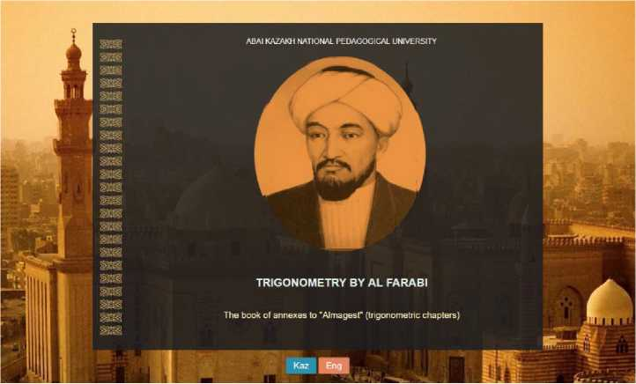

**Figure 1.** The interface of the E-Training Device

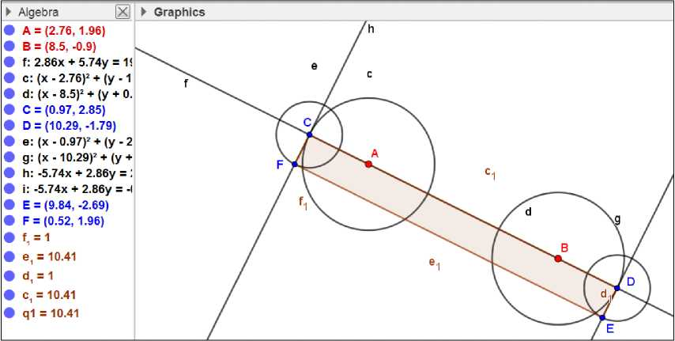

**Figure 2.** Preparing “Ruler” tool

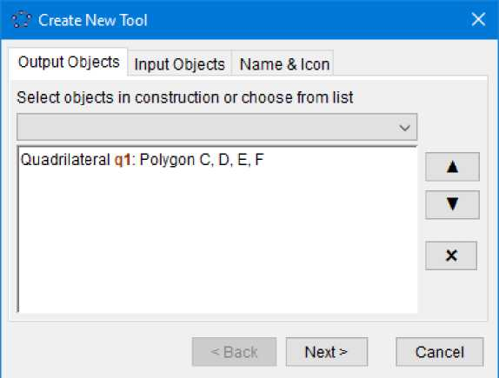

**Figure 3.** Setting up Output Objects of “Ruler” tool

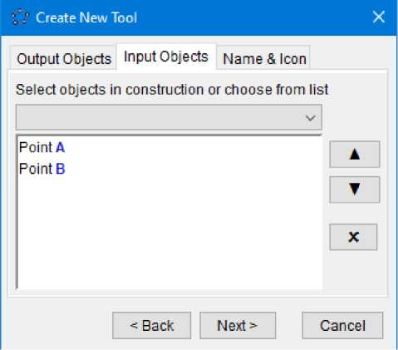

**Figure 4.** Setting up Input Objects of “Ruler” tool

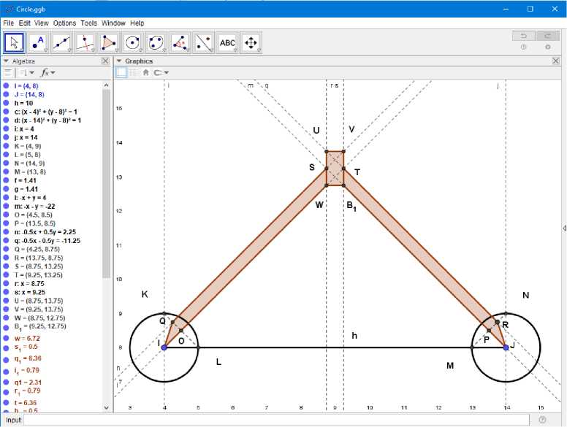

**Figure 5. “**Divider Compass” tool

**Figure 6.** “Pencil” tool

Ei®i*

Button **■кнопка1 кнопкаЮ •кнопка11**

**кнопка12**

**кнопка13**

**кнопка14  
кнопка!5**

Basic Text Color Style Position Advanced Scripting On Click On Update Global JavaScript

1. function ggbOnlnit() {}
2. function kadam(X.Y) 3<

JavaScript

OK Cancel

**Figure 7.** Programming icon

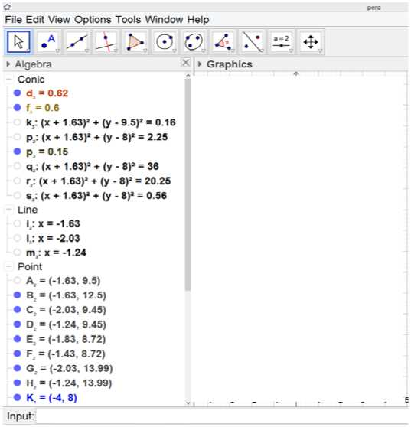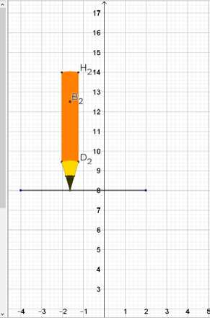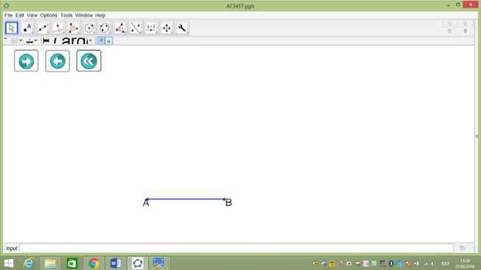

***Figure 8.*** *Buttons to make constructions*

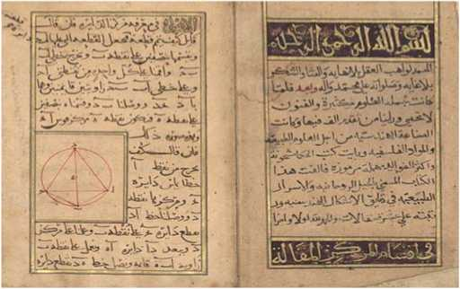

**Figure 9.** The first page of Al-Farabi's “Book of spiritual sophisticated techniques and natural secrets regarding peculiarities of geometric figures”

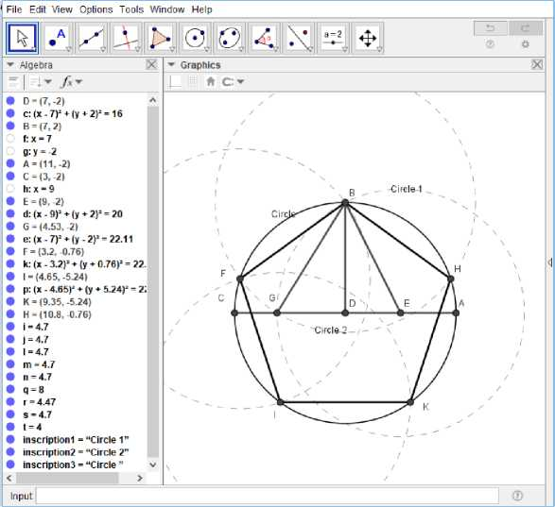

**Figure10.** Drawing an equilateral pentagon fit in a circle

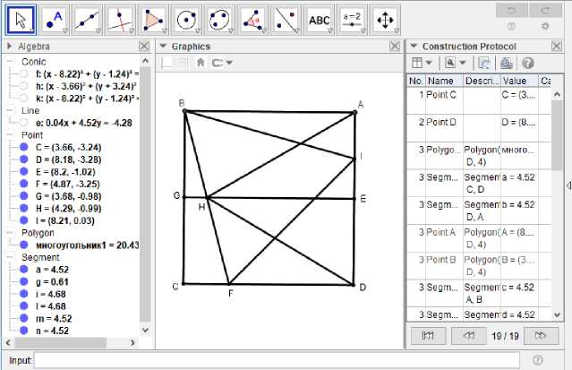

**Figure 11.** The third method for fitting a triangle into an equilateral rectangle

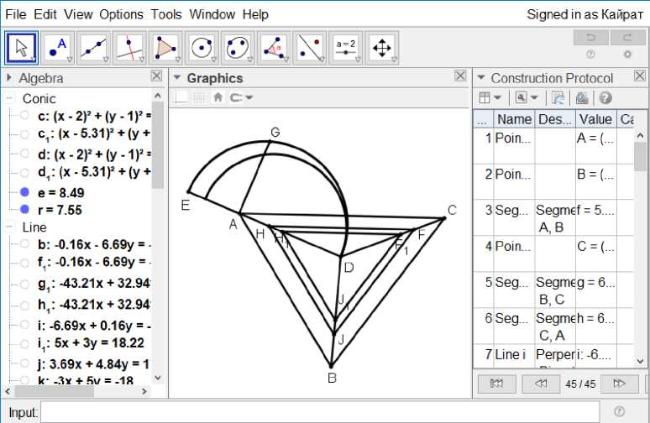

**Figure 12.** Procedure for constructing triangles inside the triangle ABC similar and equaling its half, one third, or otherwise

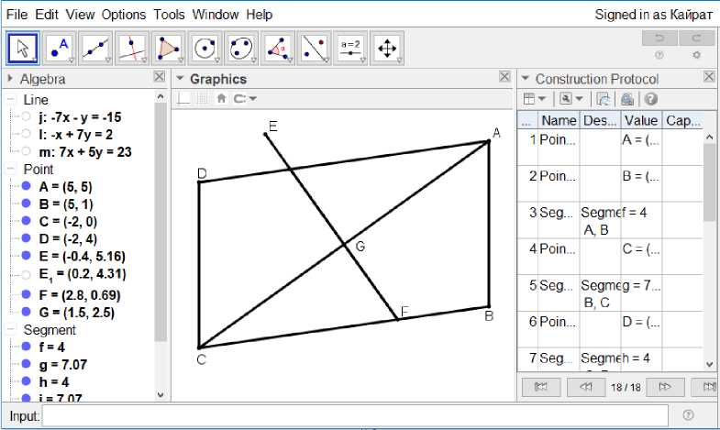

**Figure 13.** Dividing the parallelogram by a line

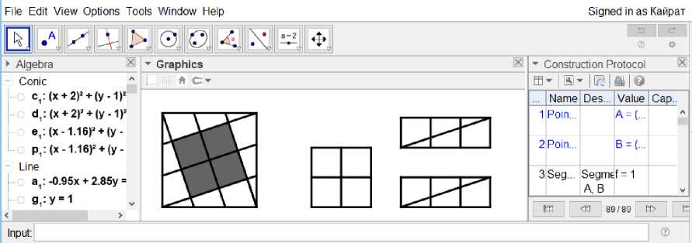

**Figure 14**. Arranging a square out of ten equal squares

**Figure 15.** Arranging a square out of seventeen equal squares

**Figure 16.** Procedure for dividing a sphere into four equal parts to obtain an equilateral triangle with two equal sides

B

**Figure 17.** Depiction of dividing a sphere on a flat surface

**E**

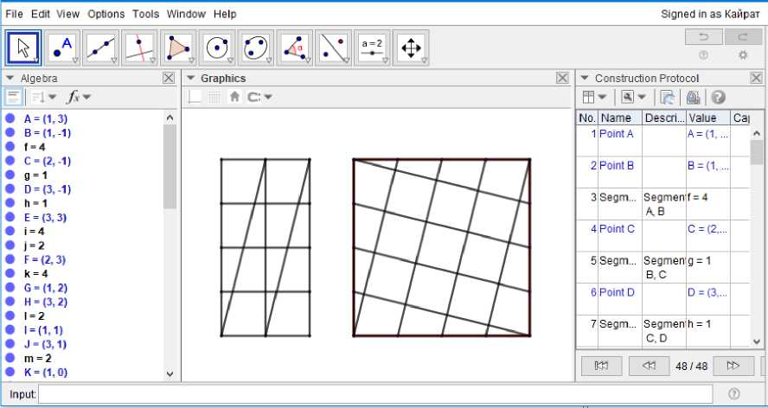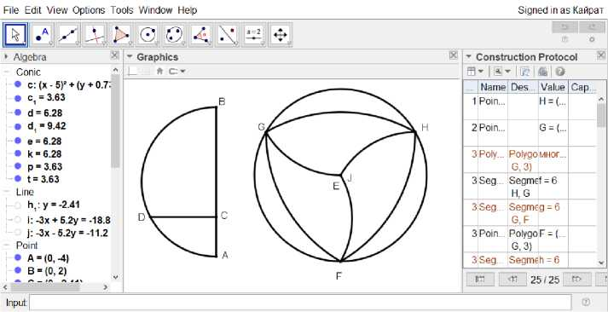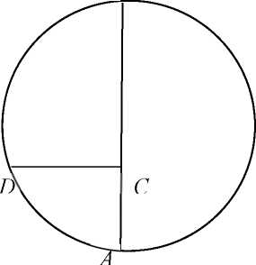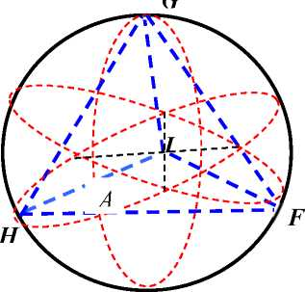

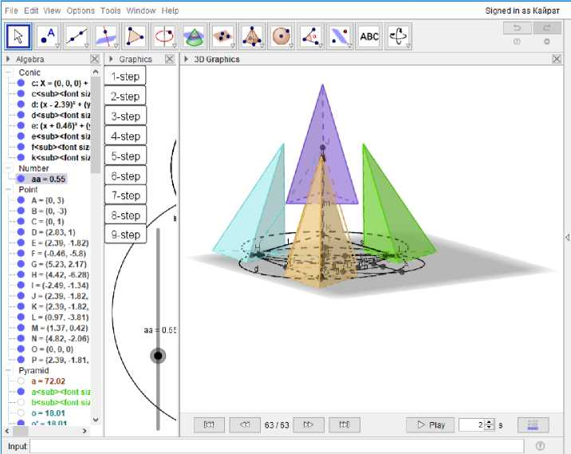

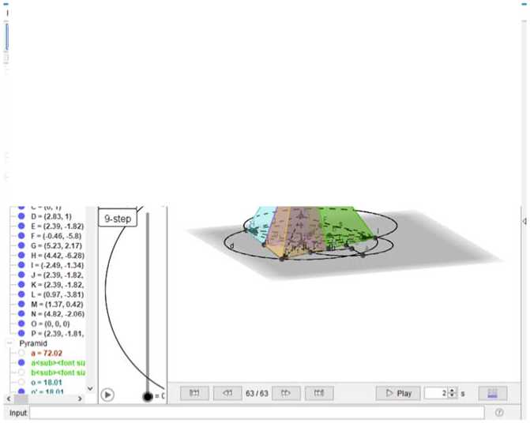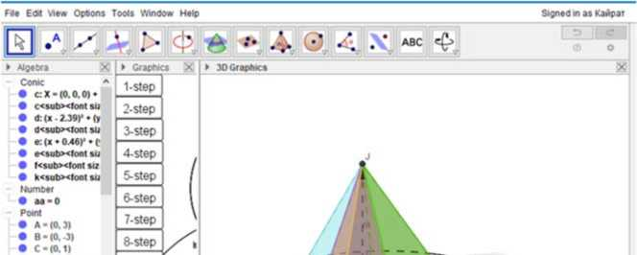

**Figure 19.** Procedure for dividing a sphere into four parts to obtain an equilateral and equiangular triangle

**Figure 18**. Procedure for dividing a sphere into four parts to obtain an equilateral and equiangular triangle

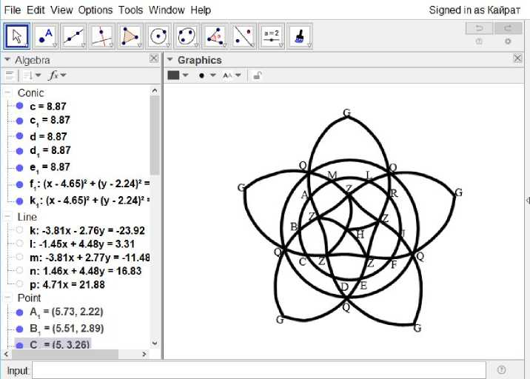

**Figure 20.** Procedure for dividing a sphere into twenty equal parts to obtain an equilateral and equiangular triangle

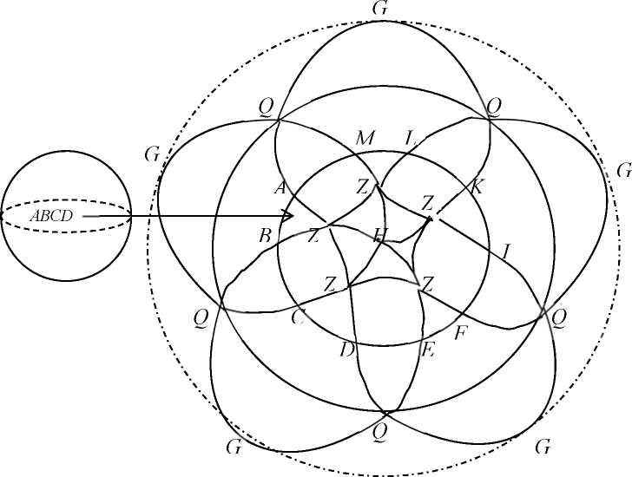

**Figure 21.** Dividing a sphere into twenty equal parts

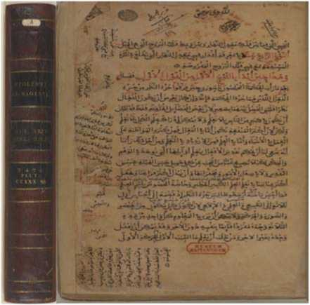

**Figure 22.** Start page of “Almagest” book with a seal indicating ownership of the British Museum

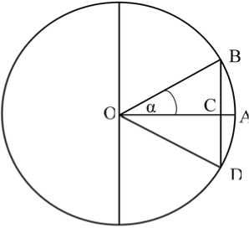

**Figure 23.** Replacing a chord by a sine

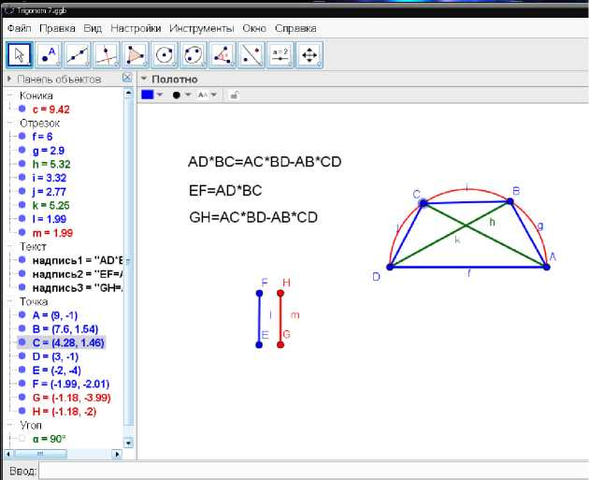

**Figure 24.** Determining of chord value with the known difference between chords of the other two arcs